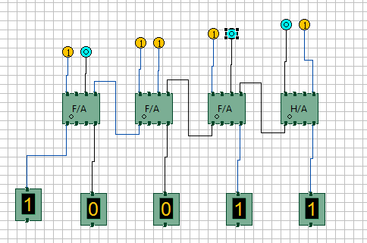

FIG1: INPUTS: A3A2A1A0=0101, B3B2B1B0=1110 OUTPUTS:SUM 0011 CARRY 1

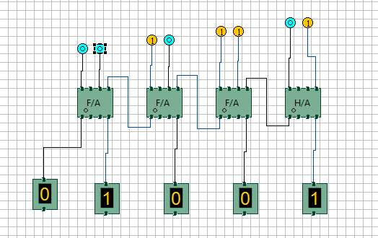

FIG 2: INPUTS:A3A2A1A0=0011,B3B2B1B0=0110 OUTPUTS:SUM=1001 CARRY=0

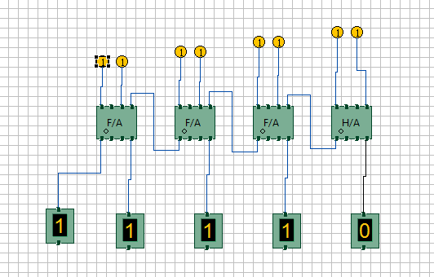

FIG 3: INPUTS A3A2A1A0=1111,B3B2B1B0=1111 OUTPUTS: SUM=1110 CARRY=1

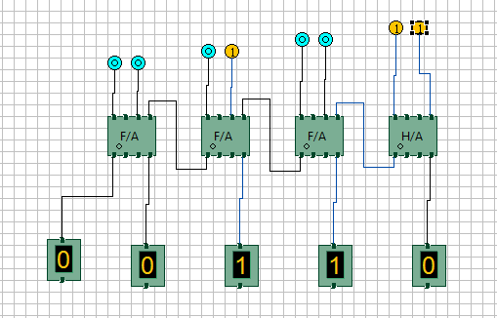

FIG 4: INPUTS: A3A2A1A0=0101 ,B3B2B1B0=0001 OUTPUTS: SUM=0110 CARRY=0

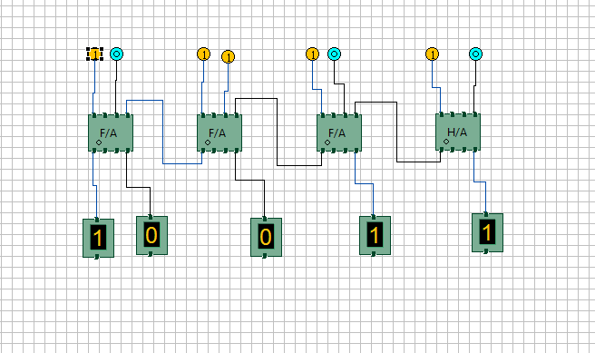

FIG 5: INPUTS:A3A2A1A0=0100,B3B2B1B0=1111 OUTPUTS: SUM= 0011 CARRY=1